Dear Club Secretaries,

**Scottish**athletics realises that clubs have difficulty in recruiting club officials to help at Club Championships and league matches. It is at a point now that Club are losing valuable points for not supplying Qualified Officials.

To help remedy this situation we have put together a “Club Officials Mentoring Programme”

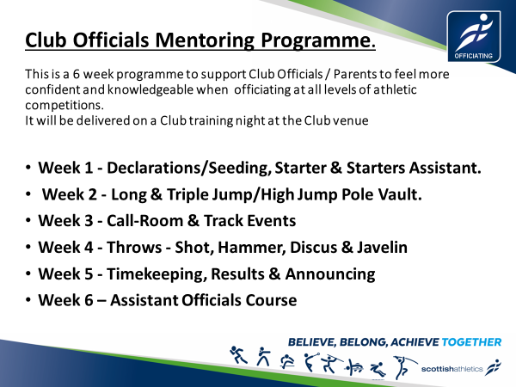

* **What is the Club Officials Mentoring Programme?**

The programme is designed to take away the fear factor from parents and volunteers, giving them the basic knowledge in all the different disciplines and increasing their confidence when officiating at all levels of athletic competitions.

* **Who delivers the training sessions?**

The programme is designed to be delivered on a Club night at the club venue in a practical way by local friendly Officials. Delivered over 4-6 weeks and tailored to suit your club needs.

* **What happens if a volunteer can’t attend every week?**

It doesn’t matter if volunteers don’t attend every week as all will be covered on the last week during Assistant Officials Course.

* **Will our volunteers be qualified officials by the end of the course?**

If they attend the Assistant Officials Course on the last night and are PVG checked, they will get qualified straight away.

* **How can our club get involved?**

Contact Officials Development Officer Shona Malcolm – [shonamalcolm@scottishathletics.org.uk](mailto:shonamalcolm@scottishathletics.org.uk)

* **What does it cost?**

£300. This is to cover the tutors for the Assistant Officials course and the resources.