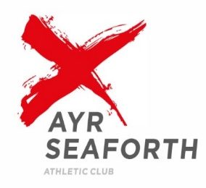
AYR SEAFORTH A.C in PARTNERSHIP WITH THE AYRSHIRE HARRIERS

OPEN TRACK & FIELD MEETING
Dam Park Stadium, Ayr
Wednesday 22nd August 2018 at 6.45p.m.
Under UK Athletics Rules
scottishathletics Permit Event

Medals will be awarded to the first 3 in every event up to and including u15

Online entries only from Friday 3 August 2018 Enter at www.online-entries.co.uk

Entries will close at 12 noon on Monday 20th August – No entries will be accepted on day of competition

Timetable : All times are approximate and subject to change to accommodate athlete availability.
TRACK | Event | U11 B | U11 G | U13 B | U13 G | U15 B | U15 G | U17 M | U17 W | SM  All | SW  All
18.45 | 600m | Y | Y
FROM 7pm | **100/80m | 80 | 80 | Y | Y | Y | Y | Y | Y | Y | Y
FROM 8pm | 800m |  |  | Y | Y | Y | Y | Y | Y | Y | Y
FIELD | Event
FROM 7pm | Shot | Y | Y | Y | Y | Y | Y | Y | Y | Y | Y
FROM 7pm | Long Jump | Y | Y | Y | Y | Y | Y | Y | Y | Y | Y
FROM 7pm | Javelin |  |  | Y | Y | Y | Y | Y | Y | Y | Y

Events may be subject to cancellation if sufficient helpers/officials are not available to officiate/help Officials/helpers should sign in at registration from 6.00 p.m.
** 100m/80m WILL BE IN REVERSE ORDER FROM SENIOR AGE GROUP TO U11

Notes

- Competition is for male and female athletes from Under 11 to Veterans and age groups are those in which athletes compete during Season 2018. Competitors must be at least 9 years old on the day of the meeting.

- Start times for all events are conditional on the level of entries received but will follow the programme order. The promoters reserve the right to change the start times to either an earlier or a later start time with all changes being announced on the day of the event.

- U11, U13 and U15 athletes may not compete in more than one race of 600M or over on the same day

- U11, U13, U15 & U17 athletes may not compete in more than 3 events on the same day

- All competitors will receive 3 attempts at horizontal jumps & throwing events. Further attempts are at
the Field Referee’s discretion.

- Field events will take place where possible to avoid clashes with same age track events.

- Shot Putt / Javelin entries will close once 30 entries accepted in total over all age groups

- Last declarations 7.15pm

Entry Fee is £7 per competitor regardless of number of events entered.

