
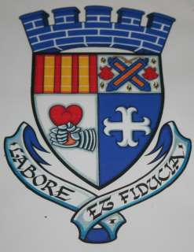

Galston Community Council
And Kilmarnock Harriers
present

The Galston 150th Anniversary 10K Cairn Race

Saturday 10th May 2014, Portland Park, Galston

Declarations from 11.00, Race Starts at 12.00 noon

Entry : £4 (Scottish Athletics members) £6 Others

Entry Available on the Day

Prizes for 1st, 2nd, 3rd and 1st Vet >40, and 1st junior, male and female

The race is a challenging 10k road run from Portland Park Galston to the Gallowhill Cairn and back, including 210 metres of ascent.
The run is part of the 150th anniversary celebration of Galston as a Borough. The event also includes a re-enactment of Robert The Bruce’s heart and the bones of the Black Douglas, passing through the town.

- - - - - - - - - - - - - - - - - - - - - - - - - - - - - - - - - - - - - - - - - - - - - - - - - - - - -

Surname |  | SAF Registration No.
First Name |  | Club
Address |  | Category (Please circle) | Sen Man, V>40  Sen Woman, V>40  Man u/20, Woman u/20
Date of Birth
E mail

Pre entries to: John H Smith, West Loudoun, Galston, KA4 8PB Tel : 01563 820506
Cheques payable to Kilmarnock Harriers

I declare that I am medically fit to participate and take part at my own risk and cannot hold the organisers responsible for any injury sustained by myself, or for any property lost during the race or from the changing rooms.

Signed : ______________________________________ Date : ________________

